Goal: Low cost fly-by-wire control system.

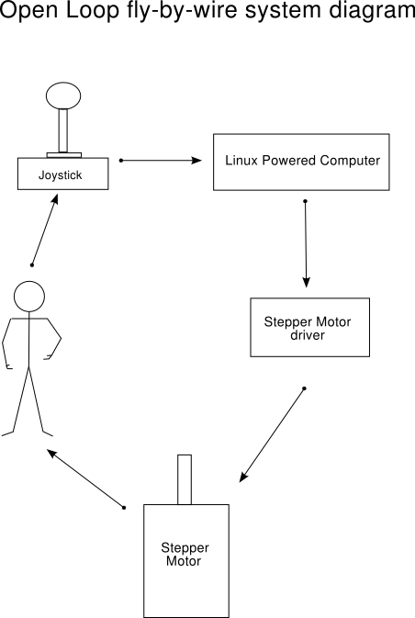

Main issues we want to avoid:

- Step Loss: Sending commands before the hardware has had a chance to process the last command.
- Syncronization Loss: The motor is physically moved without the computer knowing about it.
- Excess Motor movement: We want a nice smooth movement from the motor with out unneccessary steps and 'jitters'.
- Irregular duty cycle: We want a duty cycle close to 50% otherwise there is a chance of vibrations, also the motor efficientcy will be impaired.

Equipment used:

- Centent CN0162 stepper motor driver.
- Tormach Size 34 - 640 oz in stepper motor.
- Logitech WingMan USB joystick.
- VIA EPIA-5000 Eden 533MHz Fanless CPU mini-ITX
- 1.5GB Laptop harddrive.

Software used:

- Redhat Linux 9.0
- Joystick Wrapper Library libjsw (for joystick input)
- Mini-XML parser libmxml (for configuration file)
- gcc/gdb/make (for compiling, debuging, etc).
- ssh (For communication with computer).
- Subctrl ( the software devloped )

Result Summary:

- Stepper motor driver gets hot after about 15 minutes.
- Stepper motor takes 1 second to move 360degrees (2000 steps per second).
- No parallel port "step loss" was detected while testing.
- Powering opto-isolators from same power source as motor current was not possible.
- Changing directions more than once in 50 steps can result in vibrations
- vibrations lead to syncronization loss (the motor position jumps).
- Cheap joysticks sometimes give 'flickering' readings which oscilate between two values.

Conclusions:

Heat problems:
- lowering the stand by current value/resistor
- adding a heat sink

Motor Speed:
- limited by Parallel port communications rate
- possible to get over 3500 steps per second
- higher the speed higher the step loss risk
- Updating the parallel port too fast will result in lost steps
- Other Solutions: Scientic Sampling PCI boards, or USB Personal Measurement Devices[1].

Lost steps:
- the pilot part of the feed back loop
- Handling inconsitancies = possible step lost
- a reset button in the event of step lost
- Alterntive solution: micro switch (or reed switch) at a know point

Conclusions (continued):

Opto-isolators need clean power:
- Motor's power source caused feedback problems
- Use seperate battery solved the problems

Motor vibrations:
- Changing motor directions rapidly can cause vibrations
- Vibrations can cause motor to jump (syncronization lost)
- Mounting material can effect vibrations and harmonics
- Limit to one direction change per give steps (configurable)
- still possible for harmonic build up causing vibrations

Joystick Oscilations:
- Joystick input value oscilating
- Oscilations cause vibrations in motor movement
- At best causes unneccessary motor movement
- Set a timeout for joystick axis which is oscilating
- Higher (than timeout) harmonics still possible

[1] - http://www.measurementcomputing.com/cbicatalog/cbiproduct_new.asp?dept_id=352&pf_id=1535

